**Movie Catalog Web Application**



**Software Requirements**

**1. Introduction**

**1.1. Purpose**

The objective of this document is to provide a description of the **Movie Catalog application** (also referred to as **the App**). It will present an overview of the key functionalities.

**1.2. Scope**

This document includes high-level descriptions of the **basic functionalities of the App**, such as user registration, login, profile editing, adding movies and managing them. It does not cover any special user (Administrator) functionalities.

**2. Overall Description**

**2.1. System environment**

**Movie Catalog** can be reached online and is designed for people who want to manage the movies they watch better. **The App** is available on the **following url**:

[**https://d24hkho2ozf732.cloudfront.net/**](https://d24hkho2ozf732.cloudfront.net/)

**2.2. Key Features**

**Unregistered/non-logged users** have access only to the Landing page of the App, with the option to either **REGISTER** or **LOGIN**. On the other hand, **registered/logged users** have access to the **main functionalities**, including **Profile editing**, **Movie adding**, and **Movie management**.

**2.2.1. LANDING Page for unregistered / non-logged users**

The **Landing Page** of Movie Catalog serves as the **primary portal** for the application. It features a **sidebar**, also known as a **navigation menu**, on the left-hand side, containing buttons **for ABOUT US, OUR SERVICES, LOGIN, REGISTER,** and **COPYRIGHTS**. The design of the Landing page is **scrollable**, meaning users can **navigate** to different sections either by **scrolling** or by **clicking on the corresponding buttons** in the navigation menu.

Upon loading, the page unfolds into **various sections**, each dedicated to a specific aspect of the application.

**The first section**, **ABOUT US** welcomes the user and provides a **brief introduction** to what users can expect from Movie Catalog, emphasizing the ease of managing a personal movie collection.

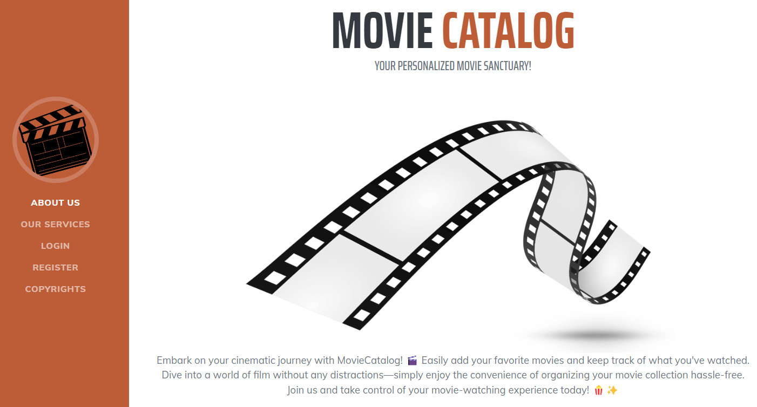

**The second section, SERVICES**, presents the **main features offered** by the website through a combination of icons and descriptive text. Users can learn about the convenience of adding new movie titles, utilizing their personal catalog, marking movies as watched, and deleting titles from their catalog. This part of the website can be accessed by **scrolling** or clicking on the **OUR SERVICES** **button** in the navigation menu.

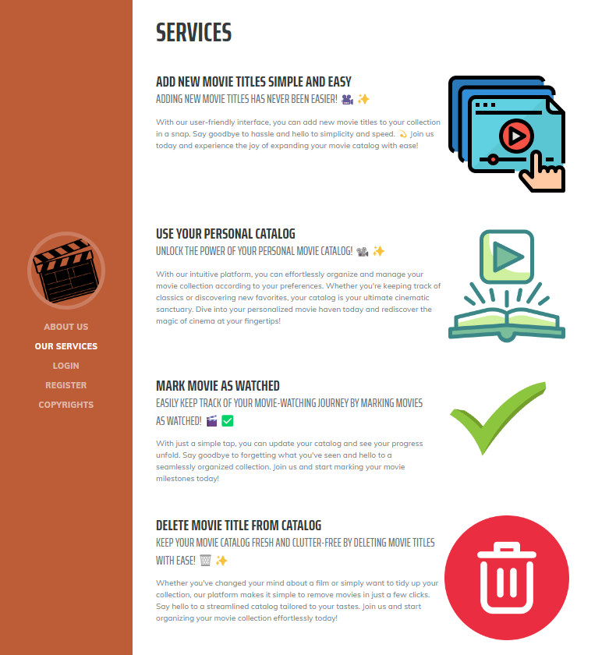

**In the third section, LOGIN**, returning users are welcomed and encouraged to access their personalized movie catalog by logging in. The section includes a **direct link to the login page**.

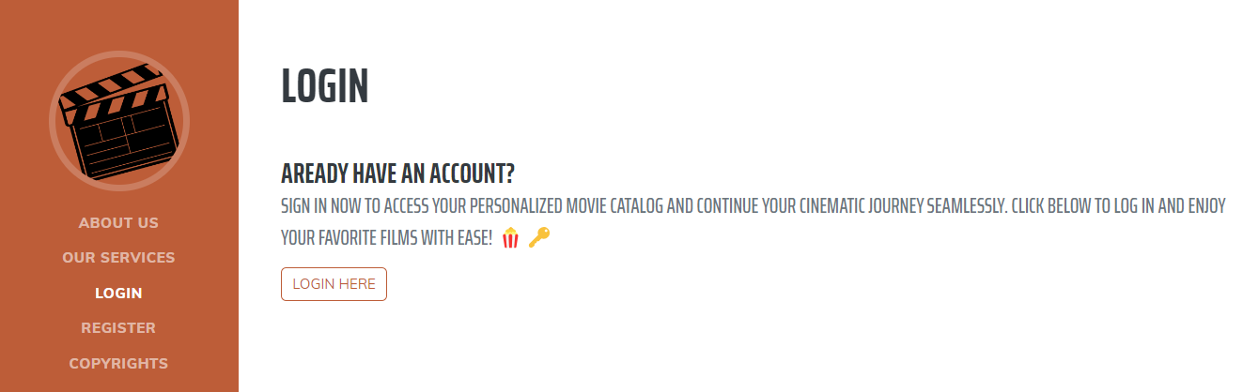

**The fourth section, REGISTER NOW**, invites new users to join Movie Catalog. It emphasizes the exclusive features available upon registration and provides a **quick link to the register process**.

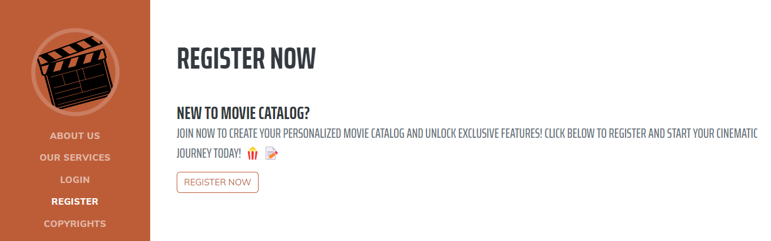

**The final section, COPYRIGHTS**, delineates the legal protections of the content and the terms and conditions for   
the Movie Catalog.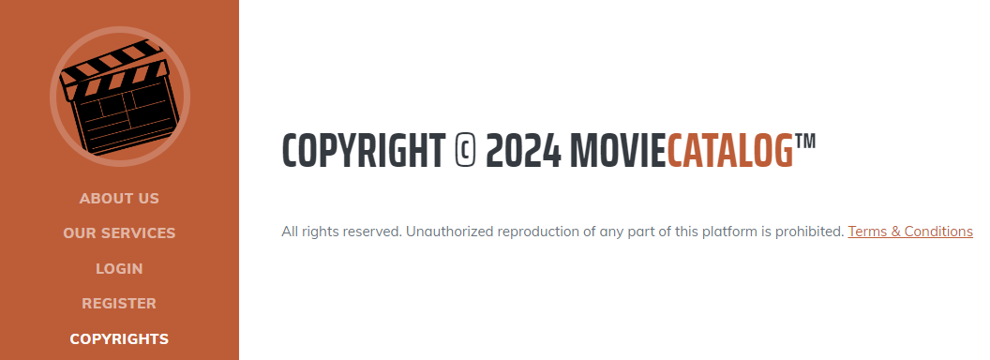

**"Terms & Conditions" part of the text is clickable** and it leads to **Terms of Service page**.

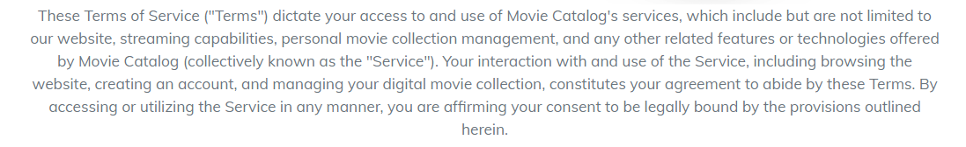

Each section is designed to be intuitive and user-friendly, ensuring that both new visitors and returning members can navigate the website with ease and enjoy their cinematic journey.

**2.2.2. REGISTER Form**

**The Register Form** is accessed by scrolling down the Home page or by clicking **Register link** on the navigation menu and then clicking on the **Register Now button**. It contains form fields for entering a **First Name, Last Name, Username, Email, Password,** and **Repeat password**. The form also includes a **Register button to submit the form**. The acceptable requirements for each field are specified as follows:

**First Name:** A 1-80 character field, accepting all character types.

**Last Name:** A 1-80 character field, accepting all character types.  
**Username:** A 5-60 character field, accepting all character types.

**Email:** Requires a valid email address in the format 'something@domain.com'. The email does not have to be real but must be 6 characters long at minimum and follow the correct format.

**Password:** Any characters are acceptable, with a length of 6-30 characters.

**Repeat Password:** Must match password.  
Upon **clicking on Register button** and successful registration the user is redirected to the login screen.

Below the registration form is a quick link for existing members: "Already have an Account? **Login here**." This provides a fast track back to the login page.

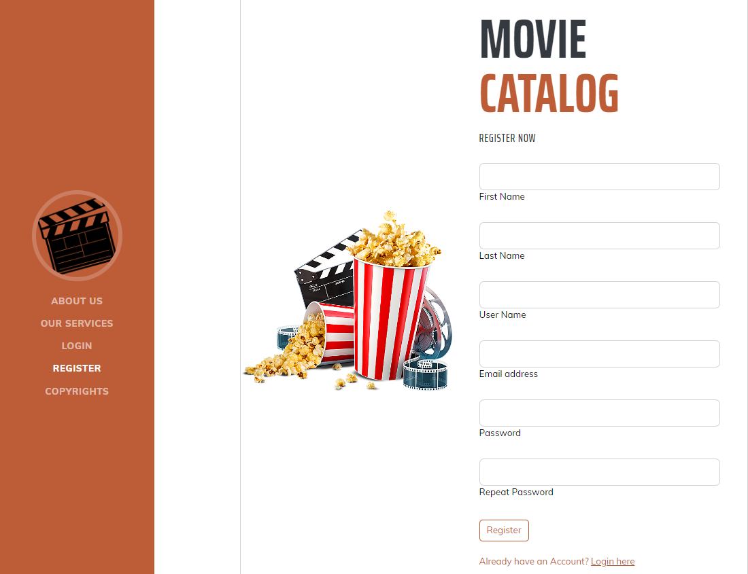

**2.2.3. LOGIN Page**

The **Login page** is accessed by scrolling down the Home page or by clicking **LOGIN link** on the navigation menu and then clicking on the **Login Here button**.

Users can **enter their email address** and **password into the respective fields**. Below the login button, there are options for those who may need to **reset their password**. **Forgot Password** functionality leads to a Restore password page, where the password can be restored by verified email.

The links to the **Register page, 'Terms of use' and 'Privacy policy'** are provided at the bottom for easy reference.

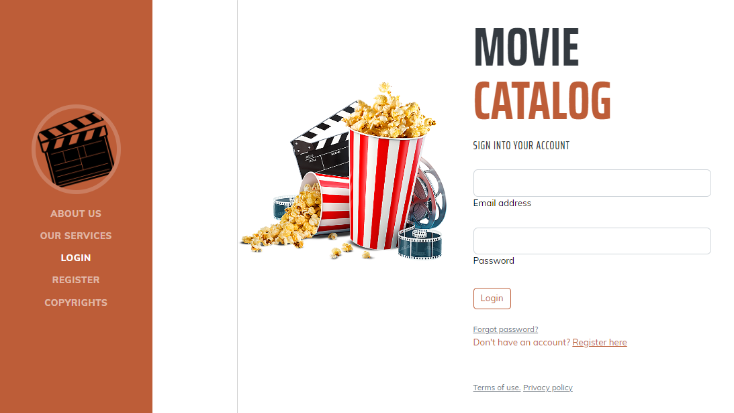

**2.2.4. HOME PAGE for logged users**

The **Homepage for logged-in users** on Movie Catalog features again a sidebar with navigation options including **PROFILE PICTURE (Empty by default)**, **ADD MOVIE**, **ALL MOVIES**, **WATCHED MOVIES**, and **UNWATCHED MOVIES**, each leading to **different functionalities of the site**. The main area greets the user by its username. A brief description underscores the site as a destination for managing and enjoying a personal collection of movies. There’s also a **LOGOUT** option at the bottom of the sidebar for when users wish to exit their session.

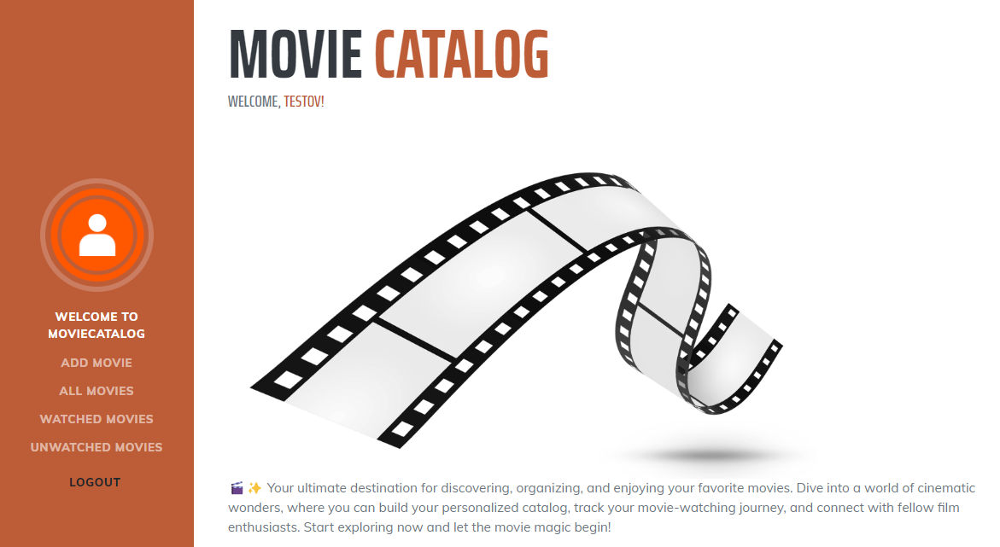

**2.2.5. PROFILE INFO PAGE**

The **Profile Info page** is accessible for logged users by **clicking on the profile icon/picture on the Sidebar**. It includes a **default empty profile picture**, the username and the email of the current user, three counters for movies: all movies, watched movies, non-watched movies, **each set to 0 by default**. There is also an **Edit button**.

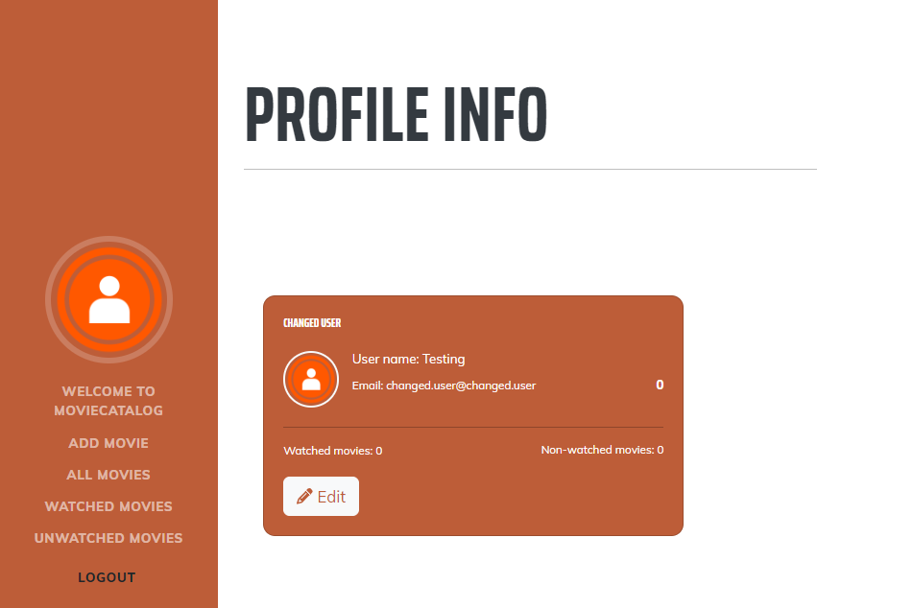

**2.2.6. EDIT PROFILE Page**

Accessible from **Edit button on Profile Info**, this page allows **users to** **edit their profile information**, including **First name**, **Last name**, **Email**, **Username** and also to **add** **Profile image** (picture is not uploaded, but must be a **valid URL of a picture,** for example http://......jpg),

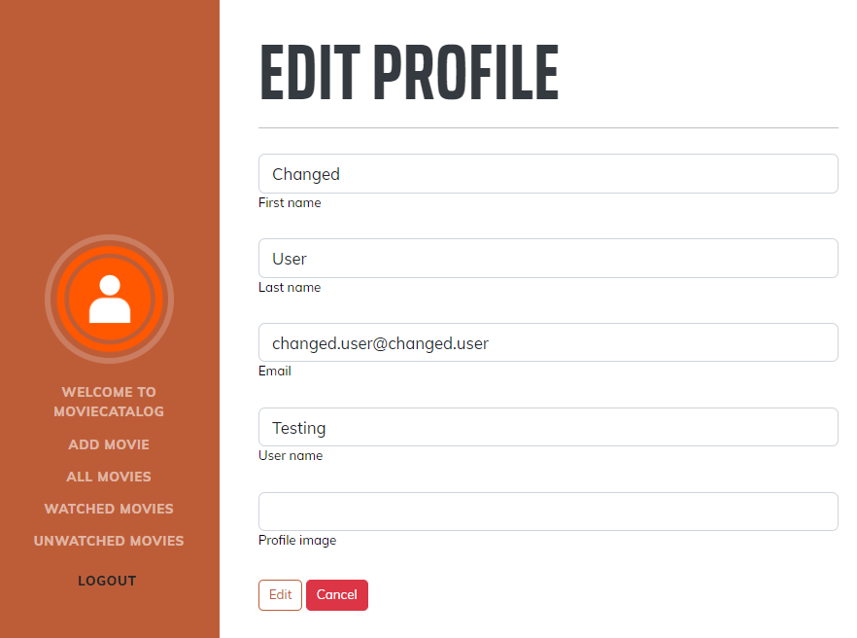

Changes are **saved by clicking the Edit** button, or **discarded with Cancel.**

**2.2.7. ADD MOVIE Page**

When users click on the **Add Movie** option in the sidebar of Movie Catalog, they're directed to a form where they can enter details about a new movie to add to their catalog. The form requires a **movie title, with a minimum of 1 character and a maximum of 120, and allows for a description up to 256 characters.** The **title and the description are required**. Users can also provide a poster URL, which must match standard image file formats, and a **YouTube trailer link**. There's also an option to immediately **mark the movie as watched** before submitting the form with the **Add** button or canceling with **Cancel**.

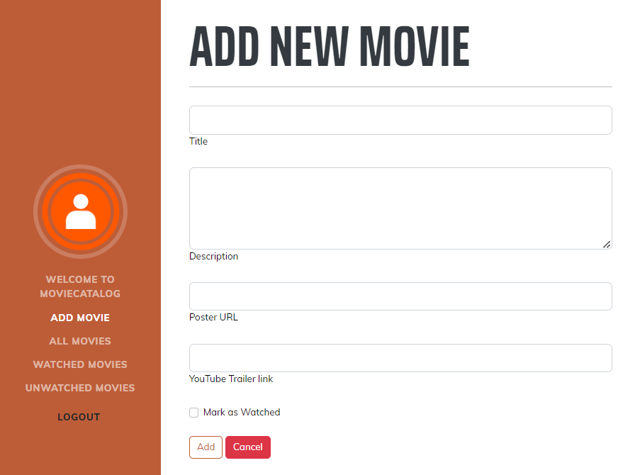

**2.2.8. ALL MOVIES Page**

Upon adding a new movie user is redirected to **ALL MOVIES** **page**, which also is available through the Sidebar. On the All Movies page of Movie Catalog, users are presented with a **display of their entire movie collection**. Each movie in the catalog is showcased on a dedicated card that includes the title and a brief description, which are mandatory fields. If provided during the addition process, the movie's poster and a link to its YouTube trailer are also displayed, enhancing the visual appeal and providing quick access to the trailer. For each movie, there are options to **View details, Edit, or Delete**, allowing for easy management. Additionally, users can quickly **mark movies as watched or unwatched** with corresponding buttons. The movies are paginated, with this page showing three movies, and navigation options to move between pages.

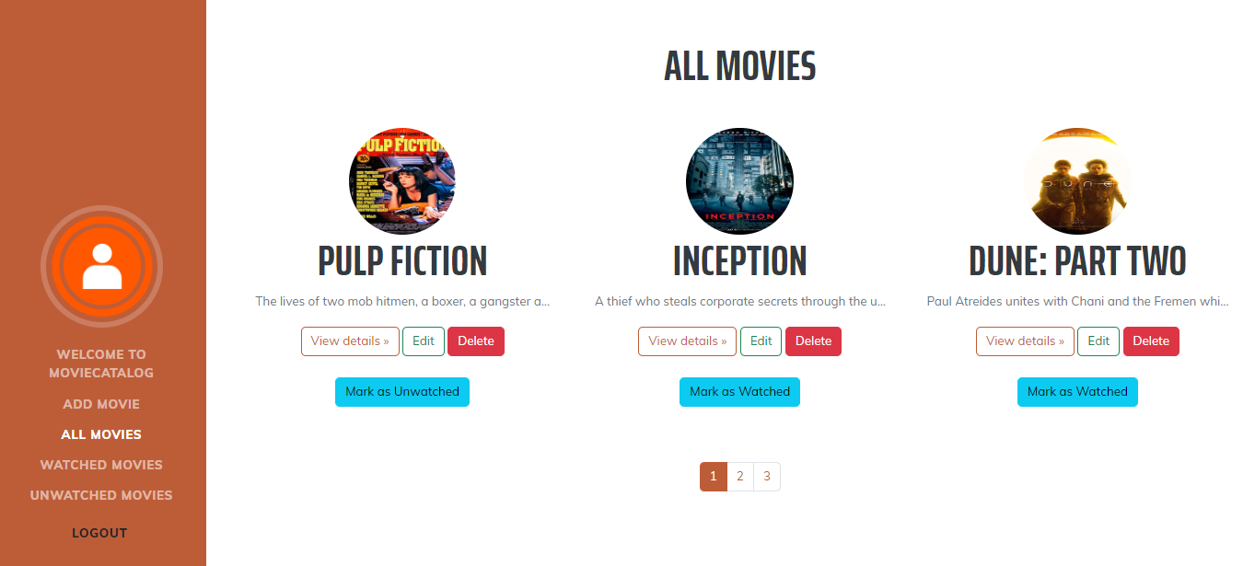

**2.2.8. WATCHED / UNWATCHED Pages**

In the Movie Catalog, both the **WATCHED** Movies and **UNWATCHED** Movies sections display movies similar to **ALL MOVIES** Page. Users can interact with each movie card through options to **View details, Edit, or Delete** the movie. Additionally, each movie can be marked as Watched or **Unwatched** depending on its current status, allowing users to easily manage their viewing history.

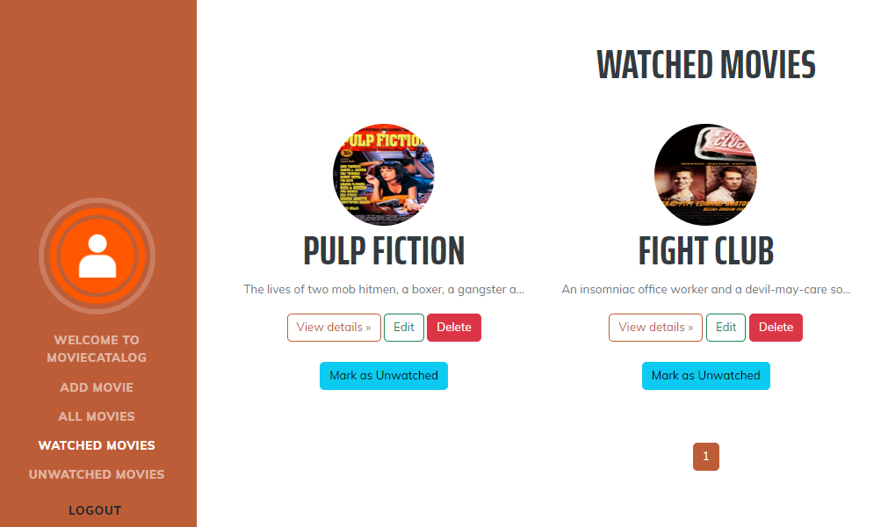

**а. View Details**

Available after clicking on **VIEW Details button**. The user is able to VIEW the movie. Also have the option to EDIT it or navigate back to the previous page.

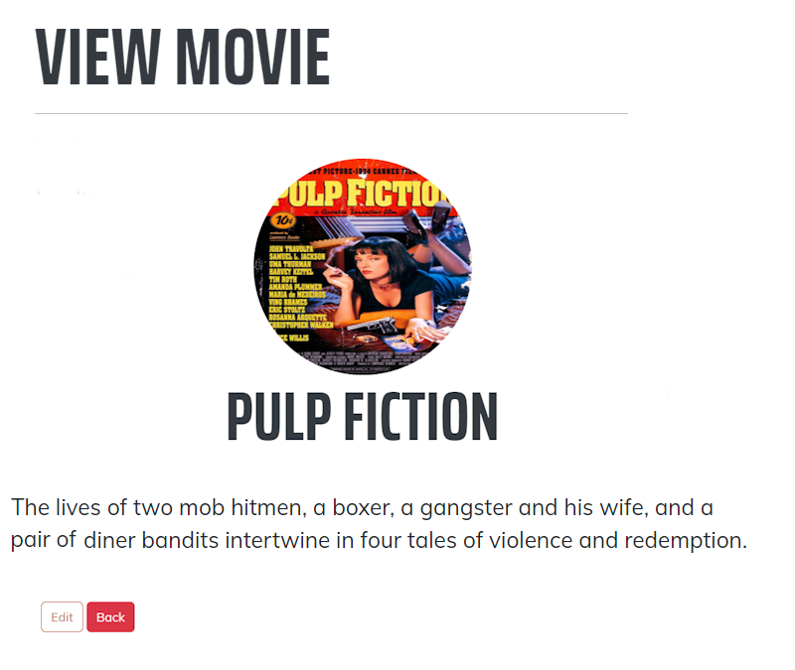

**b. EDIT**

Available after clicking on **EDIT button**. All details of the movie is editable, including: Title, Description, Poster URL, YouTube Trailer link.

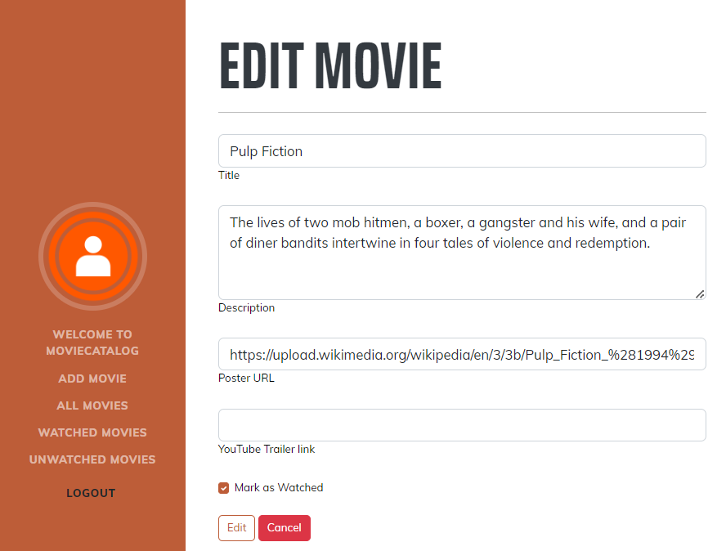

**c. DELETE**

After clicking on **DELETE button**, the user is asked to confirm the deletion with simple **yes/no option**. If yes is chosen, the movie disappears from the collection.